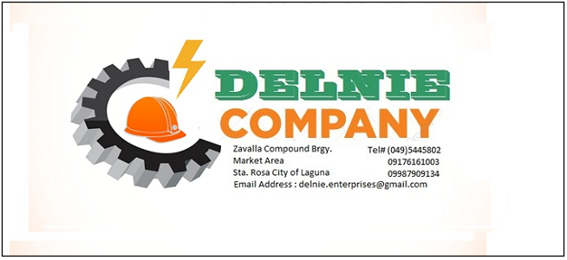
(FORMERLY DELNIE ENTERPRISES)

DCOQ 4109-23 Rev. 2
16 June 2023

PRICON MICROELECTRONICS
Barangay Diezmo, LISP 1
Cabuyao City, Laguna

ATTENTION : MS ANA MARIE M. NUEVA
Cc : MR. ROBERTO M. PACHECO
MR. HENRY DE GUZMAN

SUBJECT : ELECTRO-MECHANICAL WORKS

Dear Sir:

We would like to thank you for giving us the privilege to quote your esteemed company for the above mentioned project and we trust you will find our offer reasonable according to your requirements.

I. PROJECT : ELECTRO-MECHANICAL WORKS

II. SCOPE OF WORK :

One(1) lot Supply of labor, materials, tools & equipment for the machine / equipment electro-mechanical works @
NEW GRINDING AREA to wit :

- MECHANICAL WORKS
- Installation of machine/equipment compressed dry air pipeline (2 sets) tapped to existing overhead CDA line to include isolation valves & fittings.
- Supply & installation of flexible aluminum exhaust hose (2 sets) tapped to existing flexible exhaust hose using Y- connector
- Painting works

- ELECTRICAL WORKS
- Installation / laying of one (1) set 3 x 5.5mm² THHN wire ground from power panel to machine / equipment in wire tray & flexible hose. Existing 5.5mm² wires will be utilized where 5.5mm² additional wires will be supplied to complete the total wire length requirement for the two (2) machines
- Installation of ¾” EMT drop pipe per machine equipment.
- Painting works

- TESTING & COMMISSIONING

III. PROJECT COST (VAT Exclusive) :

A. TERMS OF PAYMENT : 50% down payment
50% progress billing

B. DURATION OF WORK : 4 - 6 working days

C. VALIDITY OF QUOTE : 7 days

Hope you find the above in order and we look forward to be of service to you. If you have further queries, please feel free to contact the undersigned.

Yours truly,

_____________________
ERNESTO L. LIJAUCO
General Manager

